information system - collect, process, store and distribute information

MIS involve three primary resources: technology, information, and people.

Elements:

1. Hardware- computers, servers, storage devices, and networking equipment (infrastructure)
2. Software- operating systems, application software( programs and applications)
3. Control - rules, policies, and protocols(procedures and processes)
4. Databases
5. People
6. Telecommunications and networks

Advantages and objectives:

1. Business decision making
2. Creating a strong and comprehensive database
3. Customer information
4. Better customer service
5. Cost Reduction
6. Real time information
7. Developing an effective communication system
8. Safety and security of information

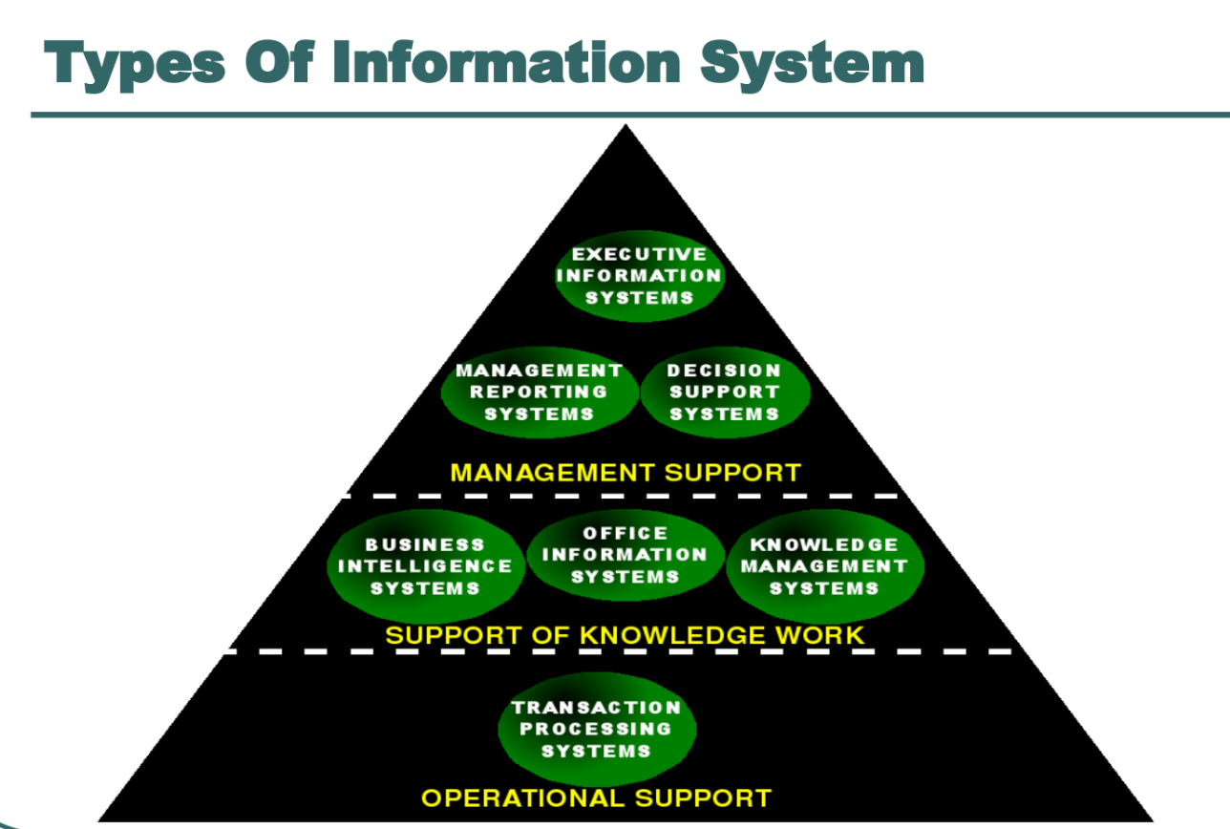

1. Transaction processing systems:
2. Operations information systems:
3. Decision support systems:
4. Expert systems:

Characteristics of MIS:

1. Management oriented
2. Management directed
3. Integrated
4. Common data flows
5. Heavy planning Elements
6. Subsystem concept
7. Common database
8. Computerized
9. User friendly
10. Information as a resource

Features of MIS:

1. Timeliness
2. Accuracy
3. Consistency
4. Completeness
5. Relevance

Components of MIS:

1. Marketing Research System (MRS)
2. Marketing Intelligence System (MIS)
3. Internal Record System (IRS)
4. Decision Support System(DSS)

Outputs of MIS:

1. Scheduled reports
2. KPI reports
3. Demand report
4. Exception report

Functions of MIS: (9/39)

Data vs information vs knowledge

| **Aspect** | **Data** | **Information** | **Knowledge** |
| --- | --- | --- | --- |
| Definition | Raw facts, figures, or symbols. | Processed and organized data that has context and relevance. | Insights, understanding, and context derived from information. |
| Nature | Objective and unbiased. | Subjective and can have some context. | Highly subjective, context-rich, and often tacit. |
| Form | Numbers, text, symbols, or images. | Structured, meaningful, and relevant. | Unstructured or loosely structured. |
| Meaning | Lacks meaning on its own. | Provides meaning or context when interpreted. | Represents deeper understanding and perspective. |
| Example | "12345", "John Smith", "Blue" | "John Smith is a customer who purchased a blue shirt." | "John Smith is a loyal customer who prefers blue shirts and is likely to make repeat purchases." |
| Use | Building blocks for information. | Supports decision-making and problem-solving. | Drives innovation, expertise, and problem-solving at a higher level. |
| Transformation | Data -> Processing -> Information | Information -> Analysis -> Knowledge | N/A |
| Context | Minimal or no context. | Contextual and relevant to a specific purpose. | Context-rich, dependent on experience and expertise. |
| Value | Insignificant until processed. | Valuable for decision-making and action. | Highly valuable, contributes to expertise and organizational learning. |
| Source | Can be collected from various sources. | Derived from data and experience. | Often based on a combination of information and personal insights. |

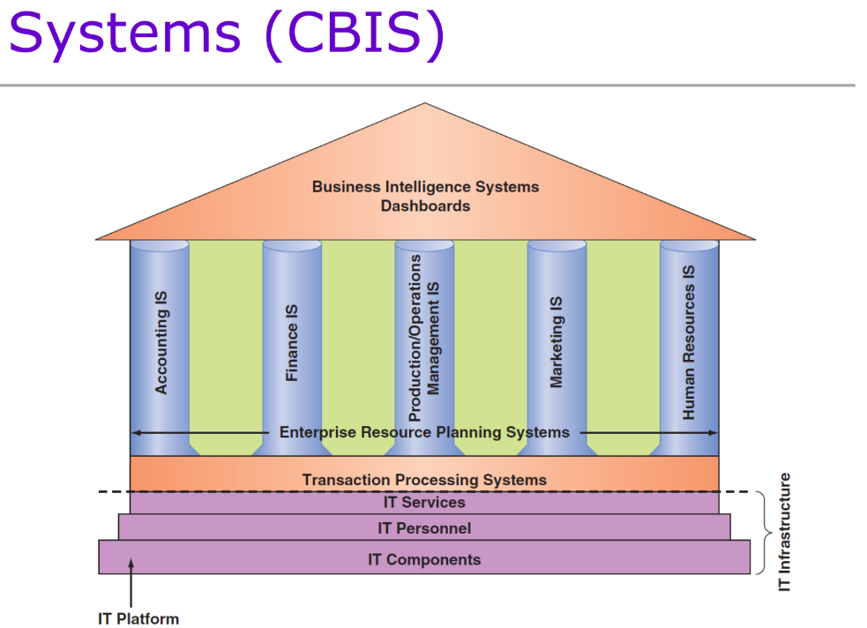

Major Capabilities of IS:

Types of CBIS:

1. Breadth of Support for Information Systems (IS)
2. Functional Area Information Systems (FAIS)
3. Enterprise Resource Planning Systems (ERP)
4. Transaction Processing Systems (TPS)
5. Interorganizational Information Systems (IOS)
6. E-Commerce Systems
7. Support for Organizational Employees
   1. Office Automation Systems (OASs)
   2. Business Intelligence (BI) Systems
   3. Expert Systems (ES)
   4. Dashboards

Positive societal effects of IS:

1. Opportunities for people with disabilities
2. Flexible Work Arrangements
3. Automation of mundane chores;
4. Improvements in healthcare.
5. Effective communication
6. Availability of information
7. Globalization and reducing cultural barriers
8. Better services

Negative societal effects:

1. Health problems for individuals;
2. Constant connectivity
3. Misinformation - especially health related
4. Availability of too much information
5. Increasing fraud
6. Lack of job security
7. Security threat

Information System activities:

1. Input activity
2. Processing activity
3. Output activity
4. Storage activity
5. Control activity

Impact of IS on organizations

1. Better flow of information
2. Improved Transaction processing
3. Supports decision making
4. Supports workgroups and team activities
5. Improved quality of goods and services
6. Provides executive support
7. Provides efficient data management
8. Improves competitiveness